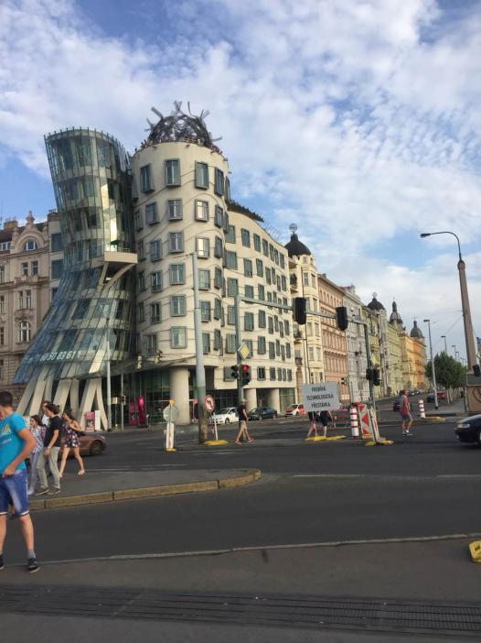
Established as early as the 9th century, Prague is destined with significance because of the massive history accretion. It has been a political, cultural and economic center of central Europe since its founding during the Romanesque and flourished by the Gothic, Renaissance and Baroque eras. Prague was the capital of the kingdom of Bohemia and the main residence of several Holy Roman Emperors. It was an important city to the Habsburg Monarchy and its Austro-Hungarian Empire. The prosperity attracts people from all over the world to settle there, transforming the city into a diversified and multi-ethnic place. Under the rule of the dictatorship for such a long time, Czechish value freedom and the hard-earned life more than anything else.
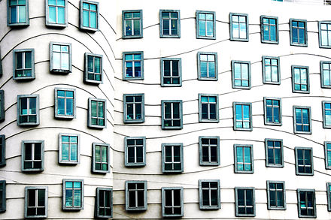

Against the grain, the dancing house is a real eye-popper for you after visiting churches repeatedly. Designed by the Croatian-Czech architect Vlado Milunić in cooperation with Canadian-American architect Frank Gehry on a vacant riverfront plot, the building was so avant-garde at its era, even today, that the first time I saw it, it reminds me of the Gowdy’s Casa Mila in Barcelona.
Focus on the glass tower to the left of the photo, it narrows at half its height and is supported by curved pillars. The best part is the bottom of it where the pillar is separated into two, resembling the legs and feet of people dancing happily and freely in a club on Friday night. They twist their bodies as much as they like and unleash themselves to their hearts’ content.
If the glass tower symbolizes the dance of a woman, then the cylindrical tower beside it could be a man. In contrast to the feminine and slim outline of the glass tower, the cylinder seems to be more tough, strong and masculine. The couple may be social dancing or dancing cha-cha with the platform between them as an emblem of holding their hands.
The side wall to the right of the photo is also appealing as none of the windows are perfectly aligned as usual. This uniqueness adds two floors to Tančící dům although it has the same height as the juxtaposition and the lines twisted at the background of the window provides the audience with a feeling of river flowing.
The most interesting fact about the dancing house is that the citizens in Prague resisted in building it at first as its design was too eerie and was hard to merge into the scene around it. However, after a debate in the city hall, the Czechish finally accepted this design and the house has become a popular tourist destination today. As time passed, the house also became an emblem of the freedom will of the Czechish which will be mentioned over and over in the following analysis.
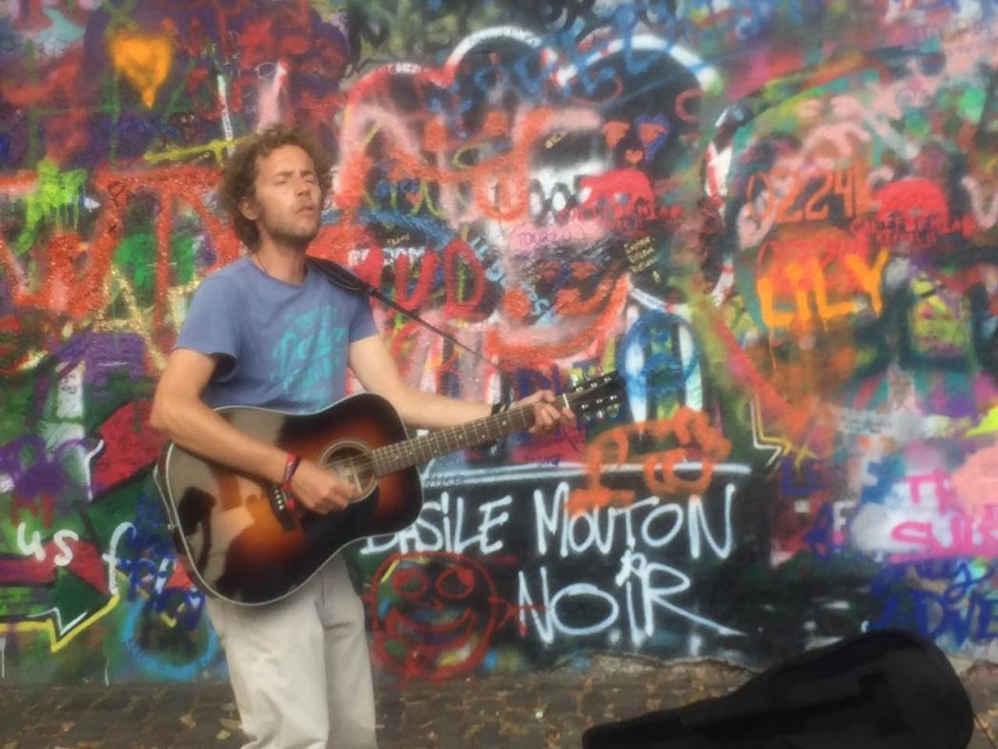

Keep walking along the Vltava River and across the bridge, you will find the Lennon Wall.
The origin of the Lennon Wall is because someone painted the wall with John Lennon-inspired graffiti and pieces of lyrics from Beatles' songs after the assassination of the lead vocal of the famous band The Beatles. However, the words that express the feeling of somber was interpreted into a protest as the Beatles was the symbolization of liberalism from the occidental countries in the eyes of the USSR. No matter how much effort the local government paid, even whiten the wall every night, the flower of color would bloom again on the wall the next day. With the lapse of time, the wall became the place where people speak out and fight against the authority and the dictatorship.
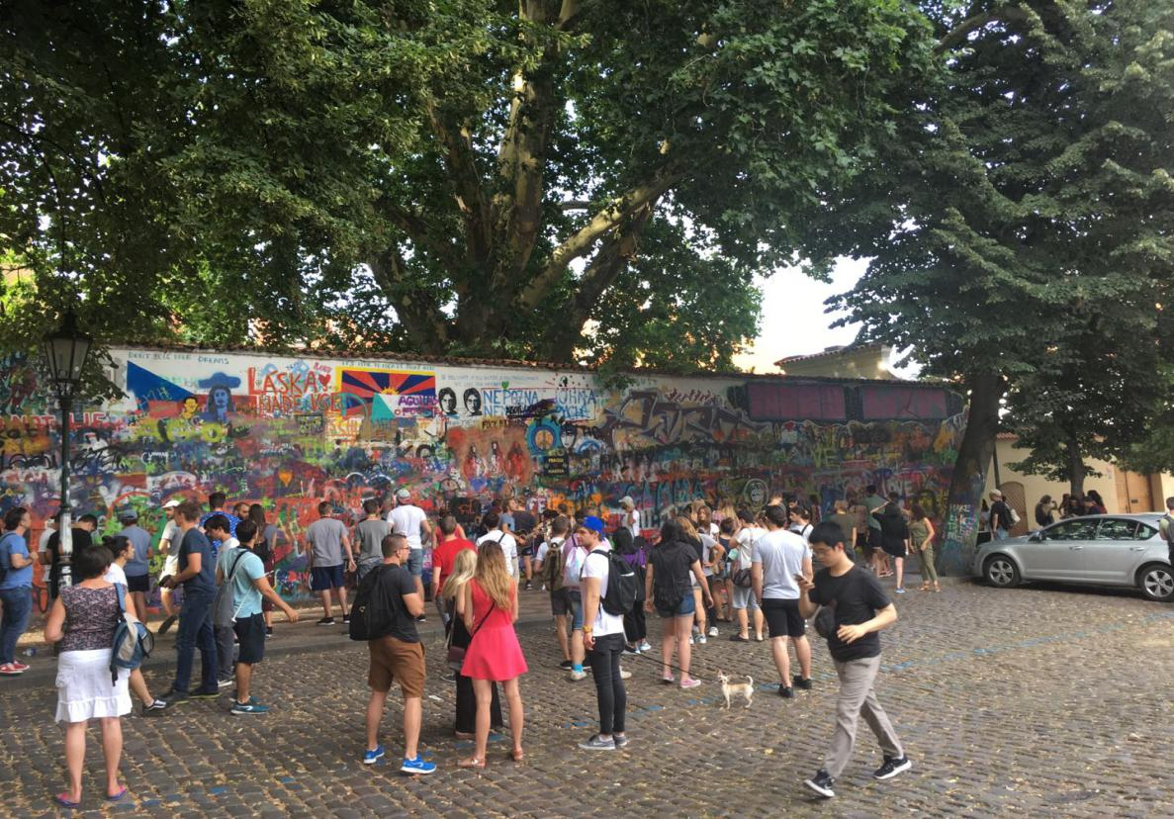
The man in the photo was singing the world-known ‘Hey Jude’ when I took it. The song is claptrap as the wall is named after Lennon and for Lennon. He is just a epitome of thousands of teenagers and youngsters in Czech republic that play musical instruments and sing in front of the wall. One of the singers told me that they are never tired of it because every day the wall will change.
The wall does change at least during the week I spent in Prague. Although, the paintings and graffities change unpredictably, they are all filled with warm and bright colors and most importantly, the portrait of Lennon. For example, on the left side, close to the center, you can find two faces. These are Lennon. To the left of the faces, you will find the huge words in red ‘Laska Nade Vse’. According to the translation form a local resident, the words encourage people to love the surroundings and love every day they lived. ‘Love all of them.’ Said the local. At the leftmost side of the photo, there are some small blue letters at the top of it, saying ‘Don’t sell your dreams.’ It is no doubt an encouragement of people to live their life, stick to their own plan and never limit their freedom due to the events happening outside. Focus on the right corner of the photo, you will see two women were actually painting on the wall at that time. ‘We love graffitiing. This is a part of our life. We really enjoy it.’ Explained them when I asked them some questions about what they wanted to express.
If you get close to the wall and touch it, a feeling of history will pounce on you immediately. At some places you can feel the thickness and, suddenly, just like going through a pit on the freeway, you fell, leaving the rift of the painting behind. If you deliberately peal off the fragment, some part of the old painting that is covered under will be unveiled. From the documentary and the introduction from the local guide, you can know that every graffiti has a story behind it and most of them was painted as a mute protest against dictator and political suppress from the USSR.
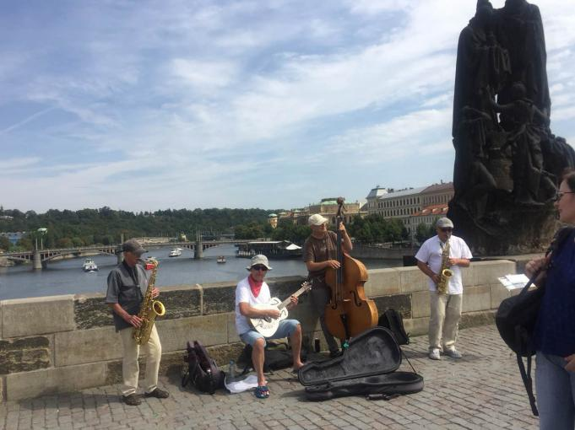
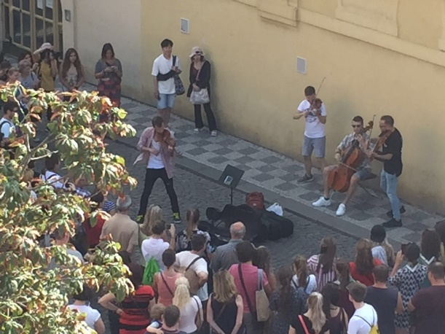
In the afternoon, the sound of musical instruments will linger around the Charles Bridge until dawn. It’s common to find different bands playing different kinds of instrument a few steps away. The photo was taken at the center of the Charles Bridge where tourists gather up to appreciate the beautiful scene of the Vltava River. In Prague, people take performing along the road as a job. The most direct evidence is that every fifty minutes to an hour, the police will check their licenses.
From the photo, you can tell that the performers are really enjoying the process. They love playing music and sharing it with people from all over the world. The man playing sax phone even improvised a solo as the people accumulate around them.
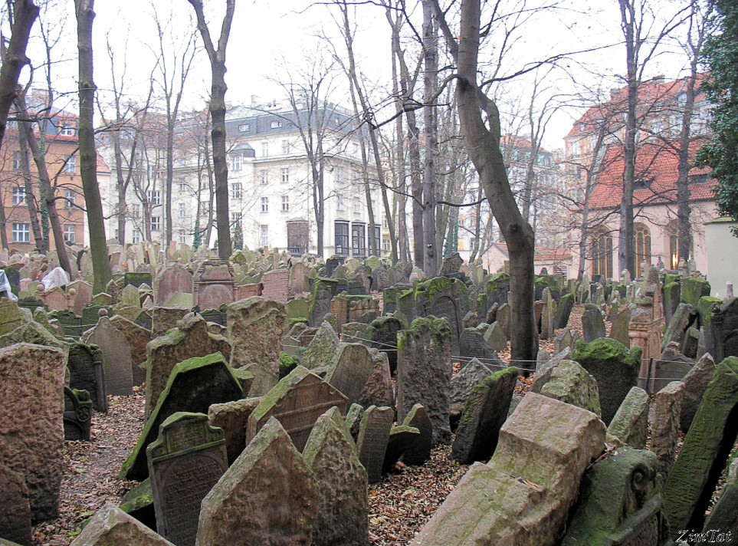
The notion of freedom is again reflected as those performers can decide when, where and how they are going to perform completely by their own will. ‘We just love doing this. This is our life and here in Prague, you have to love your life.’ Said one of the performers.
Go down the bridge and turn left, you will find a Jewish cemetery hiding in the cluster of churches and that is the Old Jewish Cemetery, one of the largest of its kind in Europe and one of the most important Jewish historical monuments in Prague. It served its purpose since the middle of 15th century.
Sharply contrast to the noise from downtown Prague, this place is all about memory, survive, life and death. Most of the Jewish slaughtered by the Nazi were buried here. There were so many, and the tomb of a Jewish is not allowed to move according to their customs, that after the cemetery was full, the Czechish bury the rest on top of the first layer and so on. It was unofficially censused that there are over 100 thousand people buried in the 12-layer cemetery.
Unlike the vast public cemetery where the gravestones were perfectly aligned, the gravestones here were carelessly positioned, even some are not elaborately carved. It’s obvious when you observe the tombstones in the frontmost role which seemed to be cut into the shape and placed there in a hurry.
To pursue freedom, you should remember the history, remember the time when you were suppressed, when you were enslaved, when you were disdained and cast aside. Walking in the cemetery, I unexpectedly had an illusion that I went back to the cemetery of revolutionary martyrs back in my home country. The freedom around us is not easy. The only way to protect and prevent it from disappearing is to imprint the history in the heart. This cemetery is the history and the Czechish struggle to hold it back even during the World War II, during the darkest time at the European Continent. The vestige of the weathering and the looming words on the gravestone is the best proof.
It seems like the Czechish people have been fighting for freedom for their whole life. From fighting for the freedom against the suppression of the medieval authority to the freedom of survival during the Second World War. From the contending the dictator to debating for the appearance of a new artistic style. It is the yearn for freedom and the life-loving spirit that keep the city developing and keep the euphonious music flowing forever.

